## Overview of the analysis:

The purpose of this analysis is to get more insights on the weather conditions in June and December in Oahu. This information will play a major role in determining if the surf and ice cream shop business is sustainable year-round.

## Results:

Based on the analysis, below are three major differences between June and December’s temperatures:

1. June had 12% more temperature observations than December
2. June’s average temperature is almost 4 degrees higher than December’s
3. The minimum temperature in December can get to 8 degrees cooler than June

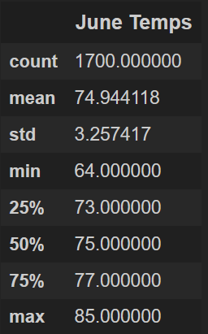 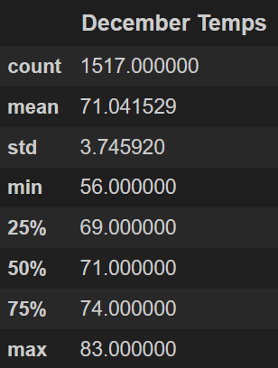

## Summary:

In summary, we can confidently conclude that both months have good average temperatures indicating that the surf and ice cream shop business should get visitors year around.

Other queries I would use are to get the average precipitation for both months. Please see below:

**Average Precipitation in June**

june_prec = session.query( Measurement.prcp ).filter( func.strftime("%m", Measurement.date) == '06' )

**Average Precipitation in December**

dec_prec = session.query( Measurement.prcp ).filter( func.strftime("%m", Measurement.date) == '12' )

Provide a high-level summary of the results and two additional queries that you would perform to gather more weather data for June and December.